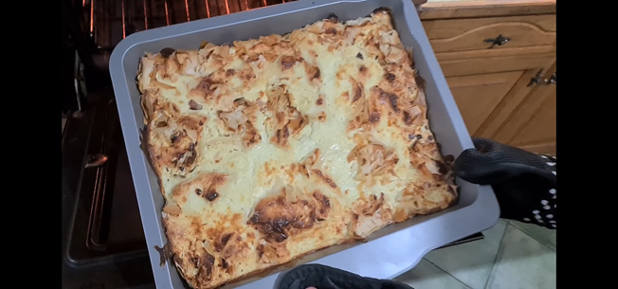
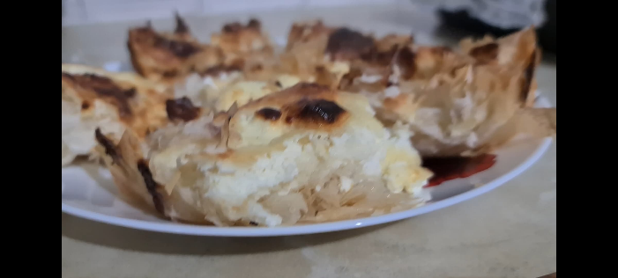
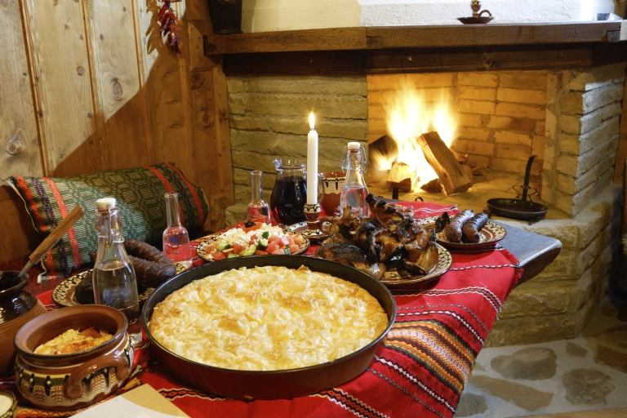
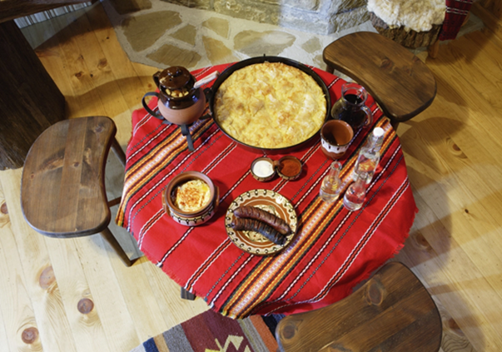
Saving a lot of times but if you want to create it more authentic see below.

Lazy way……

Phyllo pastry 1 pack
Oil just a little before a phyllo in the tray and before the mix.

Mix
You pour it up on top of the phyllo than you bake for 25 minutes on 200 degree.
Eggs 3 or 4
White Chees 250 g
Yogurt 1 cup
Baking Soda half a teaspoon

INGREDIENTS
BANITSA

BULGARIAN TRADITIONAL FOOD

Created by
Lyubka Damyanova
2020

Pictures
(italianrentalblog.wordpress.com)

It should be this way, but I show the fast one. The way of creating it is almost the same.
If you chose the second variant, use oil before the mixture inside the wrap of phyllo pastry and then after.
( www.elizabethskitchendiary.co.uk)
